Unapproved Occupant

your responsibilities
​
It is your direct responsibility to:
​
- change the lightbulbs in your home.
- report any damage or faults to your Housing Officer
- repair any damage caused by you, other occupants of the house, or your visitors.
- maintain the cleanliness of your home; this includes lawn and garden maintenance.
​
please do not attempt to repair something yourself that should be done by a licenced contractor.

our responsibilities
As the property managers, it is our responsibility to work with owners to ensure your property is kept in good condition, fit to live in and is in a good state of repair.
​
Most repairs fall into one of four categories: routine, priority, urgent or an emergency.
​
​
​
​
​
​
​
​

​
You should notify your Housing Officer and provide details of any repairs that are needed. The Housing Officer will work with you to organise a contractor to make repairs where required.
​
lodge an online repair request
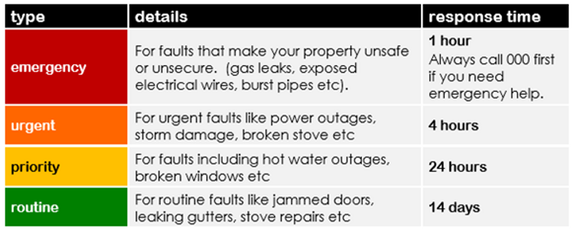
emergency repairs
Emergency repairs may include but are not limited to:
- loss of electricity
- loss of gas or water supply
- a fault to the stove, oven or hot water system
- if you cannot secure your home
- a fault or damage that could injure a person or damage the property
- a fault to the staircase or lift that means you cannot access your home
- a burst water service or a serious water service leak
- a blocked or broken lavatory system or fittings
- a serious roof leak​
- a dangerous electrical fault
- flooding or serious flood damage
- serious storm, fire or impact damage​
​
during work hours
If you need an emergency repair at your home, please call your Housing Officer immediately.
​
after work hours
If you need an emergency repair at your home after hours, please contact the appropriate after hours contractor, outlined in your Lease.

